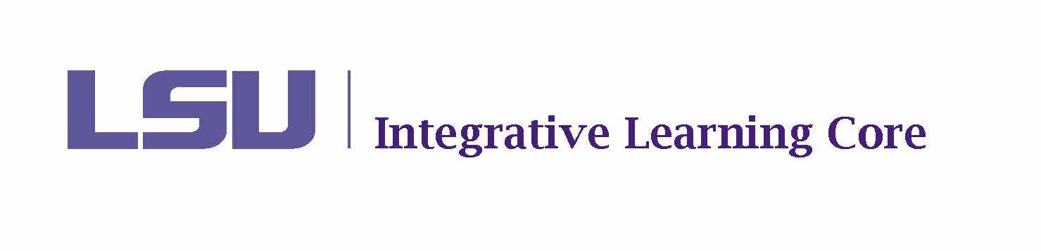

MEETING MINUTES

Faculty Senate Integrative Learning Core Committee

September 23, 2024

2:30-3:30pm

Meeting Location: 129 Himes Hall

Present Members: Aly Aly, Kayanush [Kai] Aryana, David Chicoine (Chair), Ludovico [Ludo] Geymonat, Kyla Kazuschyk, William Ma, Selena Oswalt, Jennifer Qian, Jason Wolfe (Co-Chair).
Not Present: Fanny Ramirez (sabbatical)
Present Ex-Officio: Jackie Bach, James [Jim] Murphy, Tara Rose, Haley Bourgeois, Tricia Cobb, Tachelle White
Invited Guests: Daniel [Dan] Tirone; Michelle Zerba

Agenda

- Call to Order – quorum met
- Roll Call and Introductions – Jennifer Qian introduced as newest member to the committee.
- Public Comments on Agenda Items – n/a
- Discussion
  - Election of Secretary for 2024-2025 – Selena Oswalt self-nominated as Secretary for academic year 2024-2025. Unanimous approval.
  - Brief on Membership Changes
    - David summarized informal meeting between D. Chicoine, J. Wolfe, D. Tirone (FS President), and P. Singh [FS VP] to discuss minor modifications to the ILC Committee structure and operating procedures to improve efficiency and re-align with policy. Dan Tirone invited to speak as guest to explain the reasoning for seeking these changes.
    - For clarity’s sake and to ensure better continuity during transitions of leadership, moving from a Chair and Co-Chair model to “Chair” and “Chair Elect.”
    - Reducing the size of the committee to maximize the ability to meet >50% +1 quorum requirements. This step would also allow the chair to vote on matters except for instances of a conflict of interest. Smaller committee size is given more flexibility under State meeting laws.
    - Mentioned the need to fill the two empty seats: Coast and Environment; and, Business.
    - Ludo asked how the Committee was allowed to grow outside the defined count mentioned in policy. Dan, “unclear, which is why current Faculty Senate Executive Committee is trying to rectify the shift” [paraphrase].
  - Election of Chair-Elect for 2024-2025 – No vote. Tabled until entire committee has a chance to review proposed changes before being sent to FSEC.
  - Brief on Procedures for Upcoming Course Renewals – Tachelle briefed the committee on the renewal process, instructing them to watch for the OneDrive shared folder link. Noted that OIE pre-filled the renewal forms and sends out to the committee members assigned to review respective courses. All committee members will have access to the spreadsheet indicating the dissemination of workload.

- Voting
  - Minutes from April 25, 2024 –. Kyla 1st; Kai 2nd. Approved
  - New Course Proposals
    - PHIL 1001 – Aly suggested very minor revisions to clarify the instrument used in the assessment language of the syllabus; Ludo argued that is fine to approve “as is.” Ludo 1st, Aly 2nd. Unanimous approval.
    - GREK 1002 – Jason approve “as is;” Kai approve “as is.” Ludo 1st, Kai 2nd. Approved.
      - Guest: Michelle Zerba – no critical comments or input at this stage.
    - GREK 2052 – William approve “as is;” Selena “approve with revision.” Revision requested was to clarify % of Final Exam engaged with the indicated proficiency. Revision Change Form was submitted by Michelle Zerba. Move to approve, Jason 1st, Ludo 2nd. Approved.
      - Guest: Michelle Zerba – no critical comments or input at this stage.
    - CLST 2010 – Kyla approve “as is;” David “approve with revision.” Revision sought clarification on language interchanging “test” and “essay.” Move to approve, Kyla 1st; Kai 2nd. Approved
      - Guest: Michelle Zerba – Invited to share comments on the approval process seeking clarity when a foreign language course is involved specifically. Was under the impression that all foreign language courses, regardless of course level were “Gen Ed” and met gen ed requirements with or without ILC approval. Showed older course catalogue materials that indicated Greek at the 3000-level was at one time used to meet foreign language requirements. Jim commented that 3000-levels have historically not been Gen Ed. Jason also commented that it was his understanding that only 1000- and 2000-level courses qualified for General Education credit and current policy also stipulated that they must be ILC-approved. Michelle argued that Classics kept their gen ed at 3000-level based on older understanding. Jason suggested revisiting the course designation process and contacting Courses and Curriculum for clarification on the best way to proceed.
  - ILC Course Impact Review & Renewal
    - ENVS 1127 – Kai approve “as is;” Jason approve “as is.” Move to approve, Jason 1st, Kai 2nd. Approved.
- New Business
  - Board of Regents Update from OAA – Jackie shared news that the Board of Regents is drafting new language for their GenEd requirements that may reflect an emphasis on “Skills” rather than “Disciplines” in an effort to improve the state’s ability to ensure better career readiness.
- Adjournment – Ludo 1st, William 2nd.

*It is intended that public comments may be made (1) when they relate to a matter on the agenda and (2) when individuals desiring to make public comments have registered at least one hour prior to the meeting by emailing facultysenate@lsu.edu. When registering, individuals should identify themselves; the group they are representing, if appropriate; and the topic on which they would like to comment. To ensure that the meeting is conducted in an efficient manner, each individual will be limited to 3 minutes for their public comments and the President reserves the right to limit the total number of public comments if necessary.
The LSU Faculty Senate or its Committees may meet in executive session as authorized by La. R.S. 42:17.

